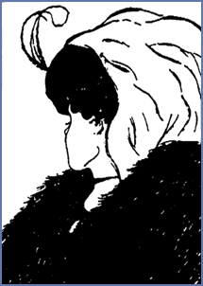
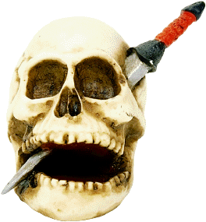
Vendetta: Scan Reading Exercise

Look over the story again and answer the questions below in full sentences.

1. What is the name of the widow’s dog?

2. What type of dog is she?

3. The widow’s house is described as small and mean in the first paragraph, why do you think the word mean is used? What does it tell you about the house?

4. What is the name of the widow’s son?

5. Write the name of the man who stabs the widow’s son to death below

6. Where does the killer of the widow’s son escape to after the murder?

7. How long does the dog’s training last?

8. What is the command given to the dog by the widow to get it to attack?

9. What tasty treat does the widow give to her dog as a reward during training?

10. What does the murderer of the widow’s son do for a living?

11. What does the widow disguise herself as to avenge her son?

Answers

1. Semillante
2. Sheep dog
3. Own interpretation- miserly. It suggests that the house is unwelcoming/ house is poor.
4. Antoine Saverini
5. Nicolas Ravolati
6. Sardinia
7. 3 months
8. “tear him, tear him”
9. black pudding
10. he is a joiner
11. an old beggar man

Vendetta: Plot storyboard

Create an illustration in each of the boxes to represent each of the main events in the story.

1. Antoine Saverini is stabbed by Nicolas Ravolati

2. The old widow promises her dead son the vendetta.

3. The old widow trains her dog to attack a man using a dummy made of straw.

4. The old widow disguises herself and sets off with her dog to Sardinia in search of Nicolas Ravolati.

6. The widow finds Nicolas Ravolati and the dog kills him by tearing his throat to pieces.

7. The widow sleeps well now that she has avenged her son’s death.

Vendetta

Task One

Imagine that someone close to you has just been murdered in a fight. You know for certain who is guilty of committing the murder but there is no chance that they will be brought to justice- in the columns below list the “Pros” and “Cons” of taking matters into your own hands.

PROS CONS

Task Two

Now that you have some ideas you can try to imagine some of the thoughts that the Widow Saverini might have had immediately after her son is killed- write her diary entry for the night of her son’s death.

