Danny Boyle’s
SLUMDOG MILLIONAIRE

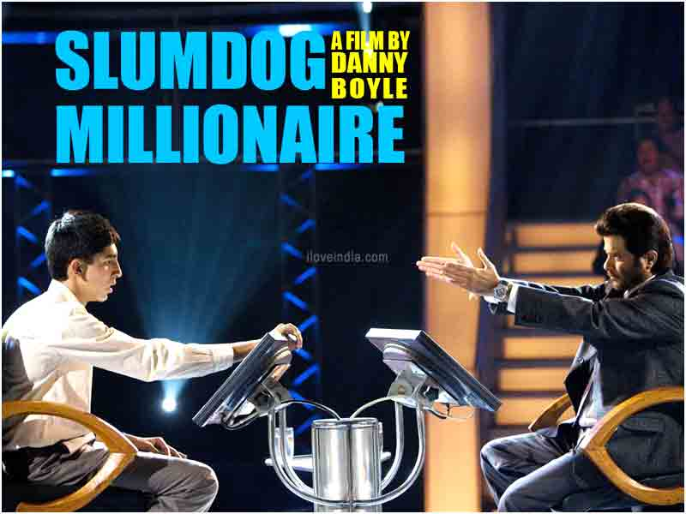

FILM UNIT

First Responses

Before you watch the film - Look at the DVD cover. 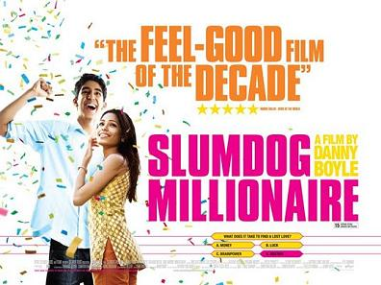
Write down what type of film (genre) you think this will be.

____________________________________________________________________________

____________________________________________________________________________

Now that you have watched the whole film once, write down what it made you think and feel.
Did you enjoy it or not?– say why.

____________________________________________________________________________

____________________________________________________________________________

The Opening Sequence Part One – The Police Cell

Look carefully at the opening sequence and study the camera angles, the music, the editing
and the character representation.

- What is the first camera shot of Jamal’s face?

____________________________________________________________________________

2. What impression do we get from this choice of shot?

____________________________________________________________________________

3. What genre of film are you made to think it will be now?

____________________________________________________________________________

4. The action switches from the police station to the game show and back again. What is this narrative technique called?

____________________________________________________________________________

5. Why is Jamal being interrogated?

____________________________________________________________________________

6. The policeman uses different tortures to get Jamal to ‘confess’. Write down as many as you can.

____________________________________________________________________________

7. Describe the final camera shot. How is Jamal framed?

____________________________________________________________________________

8. How does it represent his character at this point in the film?

_______________________________________________________________________________

9. What does the title suggest of the film’s genre?

____________________________________________________________________________

10. What simple piece of information sets up the suspense?

____________________________________________________________________________

11. What effect is created by starting the action just before the climax?

____________________________________________________________________________

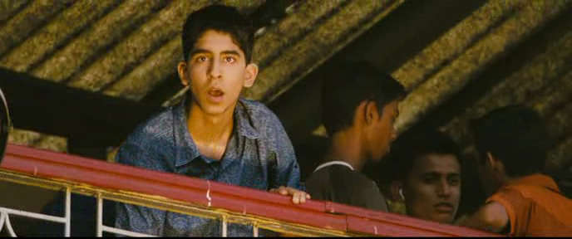
Characters are represented by what they wear, what they do, what they say and how others
treat them. However, the director can manipulate our impression of a character by using
camera shots, angles and special lighting. Editing and music can also be important in
creating a character.

12. Look again at the interrogation. Describe the difference in the lighting of Jamal and the policeman.

____________________________________________________________________________

13. How does this affect our impression of the two men?

____________________________________________________________________________

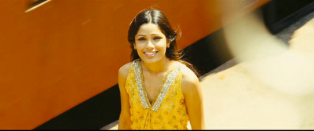

13. This is the emblematic shot of Latika, it stands out in so many ways. Why is it shown many times
in the film? Describe the shot, angle and lighting.

________________________________________________________________________________

14. How long is it on the screen for? What do you notice about the movement of the camera?
What is the effect of this?

___________________________________________________________________________

15. Danny Boyle used a relatively cheap stills camera (Canon EOS) for this shot to make it grainy
and colorful. Why do you think he did this?

______________________________________________________________________________

Describe the lighting in the game show? What effect do you think this has on the character of the
host and on Jamal?

____________________________________________________________________________

16. There is a shot of Jamal from above as he sits down. What is this shot called?

____________________________________________________________________________

17. What is the effect of this shot showing all the studio equipment?

____________________________________________________________________________

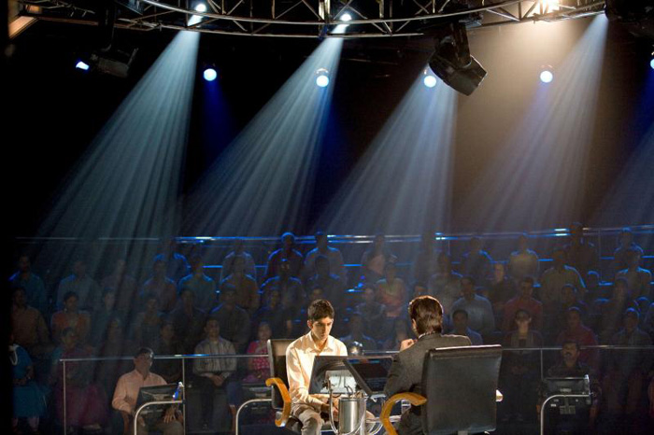

Try turning down the contrast on your television and you’ll notice the picture starts to disappear. Contrast adds drama to storytelling. Without a clear difference between the characters the
story can become dull and bland.

18. Lighting can create a dramatic contrast. Describe the three different types and colors of lighting
used in the police cell, the studio and of Latika.

____________________________________________________________________________

19. How does the lighting create contrast? What is the effect on the characters?

___________________________________________________________________________

Editing is the means by which the shots are put together. They are a crucial technique in
making the story flow well. The two aspects we will look at are the length of shots and the
transitions (such as fades, dissolves or cuts).

20. Look at the first few minutes of the film and identify some of the different editing techniques used.

_____________________________________________________________________________

21. How does the editor make smooth transitions for the flashbacks from the police cell to the
game show and back again. Give an example.

__________________________________________________________________________
____________________________________________________________________________

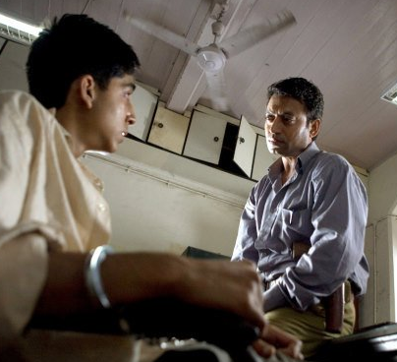

22. Now look at the whole of the opening and see if you can spot any examples of the techniques
we have looked at so far.

_______________________________________________________________________________
23. Why do you think the editor put a series of cuts between the hand spreading the money and
Jamal starting his stint on the game show?

______________________________________________________________________________

Music and sound effects are also very important in plot and character development.
(Most of us know the music that signals the arrival of James Bond, Darth Vader, Indiana Jones or
Jaws).

24. Look at the beginning. What happens immediately after Jamal is slapped?

25. Describe the effect you think is being created?

_________________________________________________________________________________

26. Watch the rest of the opening and write down any music or sound effects you notice.
What is the effect of putting this sound in?

27. Now that you have studied four different techniques – watch the chase scene and note down
any camera shots and angles, character representation, editing and music.
Try and say what effect it has on you.

____________________________________________________________________________________________________________________________________________________________________________________________________________________________________________________________________________________________________________________________________________________________________________________________
________________________________________________________________________________________________________________________________________________________


Opening Sequence Part Two – The Chase Through Juhu Slum

28. From the freeze frame of the title to the boys running into their mum – what do you notice about the soundtrack? Describe any sounds or instruments you can hear.

________________________________________________________________________________________________________________________________________________________

29. How does it help make the chase more dramatic and exciting?

________________________________________________________________________________________________________________________________________________________

30. Describe some of the camera shots and angles. How do they make the action seem faster.

________________________________________________________________________________________________________________________________________________________________________________________________________________________________________________________________________________________________________________

31. Look at the beginning – what do we learn immediately about Salim and Jamal? Think about
what they are wearing, what they are doing, where they live and how they treat each other.

Clothes______________________________________________________________________
Actions__________________________________________________________________________________________________________________________________________________
Place____________________________________________________________________________________________________________________________________________________
Sailm ‘_______________________________________________________________________’

32. There is a close-up of a real slum dog resting as the boys run past – who has the easier life do
you think? List anything else we see of the slum which might be shocking to a western audience?

____________________________________________________________________________
‘Choose a film which has an exciting opening sequence.
Show how the beginning of the film is made exciting and how it leads on to the story of
the film as a whole.
In your answer you should refer to such features as: editing, sound, or any other appropriate
feature.’
This is an essay question from 2003 Intermediate 1 exam paper

Your answer should discuss at least three techniques. Use the examples we have discussed and
make a mind map as an essay plan:

Exciting Beginning
Editing
Many short shots are put together to create a sense of speed and excitement.

33. Now write a summary of the film in the space below:

_____________________________________________________________________________________________________________________________________________________________________________________________________________________________________________________________________________________________________________________________________________________________________________________________________________________________________________________________________________________________________________________________________________

34. To finish this answer you will have to write a paragraph on how the opening sequence ‘leads on to tell the rest of the story’. Write this paragraph below:

__________________________________________________________________________________________________________________________________________________________________________________________________________________________________________________________________________________________________________________________________________________________________________________________________________________________________________________________________

We quickly see the character and relationship of the two boys. They are truanting from school
and playing cricket on an airport runway! Health and safety issues are far removed from what
we know. Jamal is daydreaming; he is not really interested in the game, Salim shouts at him to
catch the ball and curses when Jamal, with a plane landing above his head, drops it. We see a domineering older brother with an urge to win, Jamal is a boy with other things on his mind.
These characteristics will stay with them as they grow older.
As they run, the smiles and the ‘high-five’ also suggest a strong friendship which will be
important later in the film, they also look as though they are used to trouble and escaping it.
However, though the conditions are harsh, they have a mother who cares and wants them to
get an education.

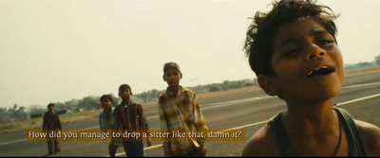

35. Jamal is abused by three different people at the start of this film – the policeman (with violence),
the game show host (with his sarcasm) and his brother (with his criticism). What impression do we get
of his character after the opening sequences?

________________________________________________________________________________________________________________________________________________________

- What do we see that tells us their mother cares for them? Is she a single mum?

____________________________________________________________________________________________________________________________________________________________________________________________________________________________________
- Which character is introduced to us in the car?

____________________________________________________________________________

- What kind of person are they and how do we know?

________________________________________________________________________________________________________________________________________________________

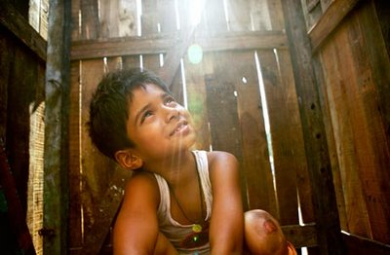
The Toilet

This scene gives us another insight into the two differing characters of the brothers.
Look at Salim and Jamal’s different attitudes and how this affects their actions.

- How is their attitude to money different?

____________________________________________________________________________

- How will this show itself when they grow up?

____________________________________________________________________________

- What are Jamal’s values? What is he willing to do to get a film star’s autograph?

____________________________________________________________________________

- What does Salim do that night?

____________________________________________________________________________

- Why do you think he does that?

____________________________________________________________________________

Salim

What Salim Does | What this tells us about him
Shouts at Jamal when he drops the catch | Critical older brother
Shows respect to Javed

Sells Jamal’s autograph

He doesn’t let Latika into the shelter

Jamal

What Jamal Does | What this tells us about him
Gets shouted at for dropping the catch | Gets bossed and criticized by his  older brother
Does not hurry up in the toilet

Jumps through the hole to get an autograph

Tells Latika to follow them in the riot

- There are quite a few differences in the characters as we can see – how does this show
- itself in terms of conflict? List all the times where there are disagreements between them.

________________________________________________________________________________________________________________________________________________________________________________________________________________________________________________________________________________________________________________________________________________________________________________________________________________________________________________________________________
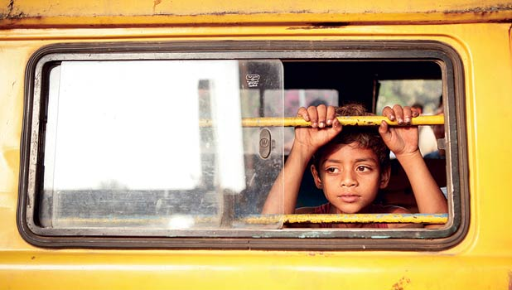

45. Maman arrives on the scene wearing sunglasses, we also see Javed the slumlord wearing them
and later the older Salim wears them when he is working for Javed. What do you think sunglasses
symbolize in the film?

_______________________________________________________________________

46. How does it help to represent what kind of character they are?

_______________________________________________________________________

47. The blinding scene is made very sinister – point out a technique which you think helps to do
this. Say what effect it has.

____________________________________________________________________________

48. Look at Salim and Jamal’s escape. How are techniques used to make it exciting?

Camera:_____________________________________________________________________
Editing:______________________________________________________________________
Lighting:_____________________________________________________________________
Character Representation:______________________________________________________
Music:_______________________________________________________________________

Editing – Montage is another technique which directors use to show a passage of time and development of characters. They use music - usually a song - as a soundtrack and by the end
of the song (one or two minutes) there is a significant change in a character. Think of the
montage in Rocky where he is jogging, many scenes of his hard training are cut in, and of
course Rocky’s theme is playing. By the end of the tune we know he has done weeks of work
and is ready for the fight.

49. Look out for the use of montage in the film – say what effect it has on the development of the
characters.

____________________________________________________________________________

50. What other technique does the director use to suggest a few years have passed?

____________________________________________________________________________
51. There are repeated close-ups of Salim counting coins. What does this tell us about him?

____________________________________________________________________________

52. What do you notice about their clothing now? What does this tell us about how successful they
have been as traders?

____________________________________________________________________________

53. What do we notice about their language? What does this tell us about their development?

____________________________________________________________________________

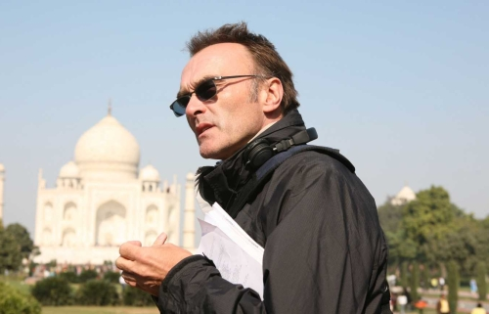

54. Before they return to Mumbai to find Latika – look at the way their clothing changes. This also tells
the audience about their characters and how they are becoming more different. Write down anything
you notice and say what you think they represent?

____________________________________________________________________________

55. Comment on the use of make-up to create sympathy for Jamal.

____________________________________________________________________________

56. How is this similar to Latika’s face when he meets her again at Javed’s house towards the end of
the movie?

____________________________________________________________________________

57. What does this tell the audience about the two characters?

____________________________________________________________________________

58. Describe the techniques used to create an effective fight between Jamal and Salim

___________________________________________________________________________________________________________________________________________________________________________________________________

______________
example 1:
effect:
example 3:
example 2:
example 4:
effect:
effect:
effect:
If you spot another type of technique other than the one you are working on,
write them down here:

Character:_________________________________________________________________________________________________________________________________________________________________________________

Music:____________________________________________________________________________________________________________________________________________________________________________________

Camera:___________________________________________________________________________________________________________________________________________________________________________________

Editing:___________________________________________________________________________________________________________________________________________________________________________________

Lighting:_________________________________________________________________________________________________________________________________________________________________________________
Essay Question on Conflict
Choose a film which involves conflict. Describe one sequence in the film which shows the conflict
in action and say how successful you think it is in holding the audience’s attention.

Mention at least two techniques in your answer.

Which characters are involved in a conflict?

_________________________________________________________________

Now choose a sequence which shows the conflict in action.

________________________________________________________________

Write down four points about the sequence which you think are successful in holding the audience’s
attention:

1.The director uses lighting to create a serious mood which keeps the audience interested.
2.___________________________________________________________________________3.___________________________________________________________________________4___________________________________________________________________________

Now write four examples of evidence which help to illustrate your points. Remember you must mention
at least two different techniques:

1 When Salim first appears in the hotel room he is lit from behind so all we see is his dark shadow on
the wall
2.___________________________________________________________________________
3.___________________________________________________________________________
4.___________________________________________________________________________

Now write four explanations for each of the points and evidence:

1. This dark shadow tells the audience that something bad is going to happen, that Salim’s personality
has become darker. This is successful in keeping the audience interested because we expect
something bad to happen,

2._______________________________________________________________________________________________________________________________________________________

3._______________________________________________________________________________________________________________________________________________________

4._______________________________________________________________________________________________________________________________________________________
How is the ending made exciting & enjoyable?
Technique 1:__________________
Technique
3:_______________
Technique
2:________________
E.g. and effect:
E.g. and effect:
E.g. and effect:
E.g. and Effect:
Essay Plan for
End Sequence
E.g. and Effect:
E.g. and Effect:
Writing a Critical Essay

Choose a film with an ending which is exciting and satisfying. Show how it is made exciting
and enjoyable.
In your answer you should refer to at least two of: editing, soundtrack, special effects, use of
camera or any other appropriate feature.

Writing a paragraph for this essay question:

Complete the Point, Evidence and Explanation with your ideas from the previous page.

(Point) ‘One of the techniques which makes this ending exciting/enjoyable is……..___________________________________________________________________________________________________________________________________________________’

(Evidence) ‘An example of this is when….__________________________________________________________________________________________________________________________________________________’

(Explanation) ‘This has the effect of…._________________________________________________________________________________________________________________________________________________________________________________________________________________________________’

Essay Paragraph Plan

Introduction:
- Put the title of the film and the director.
- A clear indication of what you will be writing about.

Summary:
Tell the story of the film. Try to keep this short (50-75) words if possible.

Paragraphs 1:
Beginning with a topic sentence, choose one technique and write about an example of its effective use.

Paragraph 2:
Begin with a linking word (e.g. another, later,) and write about another example.

Paragraphs 3 & 4:
Repeat paragraphs 1 & 2 but discuss a different technique.

Conclusion:
- Sum up and round off what you have written
- Give your personal response.
Below are five essay titles from the Mass Media section of the Intermediate 1
Critical Essay papers – can you match the topic sentences with the right essay?

Intermediate 1 Essay Titles:

1. Choose a film which involves conflict. Describe one sequence in the film which shows the
conflict in action and say how successful you think it is in holding the audience’s attention.

2. Choose a film which has sequences where special effects are important. Describe some of
the special effects and say why you found them successful.

3. Choose a film with a scene which has a lot of fast and exciting action. Show how it is made
exciting and enjoyable.

4. Choose a film with a character which interests you. Show how one of the characters is very
important in keeping your interest.

5. Choose a film with an opening sequence that creates a particular atmosphere which is important.
Say what it is and why it is important. Show how it is created using techniques.

Topic Sentences:

a. Another way the character of Salim is kept interesting is by the use of lighting.

b. The tracking shot is also an important technique in keeping this scene exciting and enjoyable.

c. The serious atmosphere is important because Jamal could go to jail and lose everything he hoped
for. One of the techniques which help to create this is the use of camera shots.

d. Excitement during the chase is also created by the use of fast music.

e. Clothing and jewellery are another important aspect of character representation and there are also
many things which Salim wears which keeps our interest in him.

f. Lighting is another very important in creating this serious atmosphere at the start of the film. We see
this with the representation of the policeman’s face.

e. Danny Boyle uses camera angles just before the fight and this is very effective in holding the
audience’s attention.
a= 4
b=__
c=__
d=__
e=__
f=__
g=__

THEMES are the ideas or message in a film which the director is trying to convey to the audience.
These are usually issues which we can all relate to.

What do you think are the main themes of Slumdog Millionaire? Think about the main characters and
how their lives could be a lesson to us?

__________________________________________________________________________________________________________________________________

What do you think the message of the film might be trying to teach us?

____________________________________________________________________________

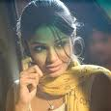
Glossary of Film Terms

Birds-eye-view
This shot is taken from above and looking directly downwards. Helps to establish setting.

Close-up
This puts the character’s head and shoulders in the frame and is important to show what a
character is thinking or feeling.

Big close up
Head only, used when expressions are important

Crane shot
This is where the camera is mounted on a crane and the frame moves up and along. Can add
interest to an establishing shot.

Cross cutting
This is an editing technique where the action keeps switching from one scene to another and
back again to suggest that the events are happening at the same time.

Transitions
Where different scenes are joined together in cuts (where one image is replaced by another), dissolves (one image dissolves into another to show a passage of time) or fades (to and from
black usually mean that time has passed).

Dutch tilt or Canted
This shows the frame tilted to one side. Can suggest disorientation, a strange atmosphere or
mood.

Establishing Shot
This is a wide angle shot which establishes the setting of the scene.

Flashback
This technique allows the director to provide the audience with back story, incidents that have happened prior to the start of the film.

Hand-held Shot
This helps the audience feel that action is happening at that moment and they are in it.

High angle
If a character is filmed from above they will look smaller and perhaps appear to be more
vulnerable or insignificant.

High key lighting
This is bright lighting with low contrast.

Long shot
This shot shows a character as quite small in comparison to their surroundings and is useful in showing the setting the character is in. Shows their figure head to toe.

Low Angle
If a character is filmed from below, the character will look larger and perhaps appear to be
stronger or more dominant.

Low key Lighting
This is dim or dark lighting. Can be used to create a sinister mood or character. Pronounced
shadows and dramatic contrasts.

Panning
This is where the camera moves sideways to follow a moving object. It conveys a sense of
movement.

Point of view shot
This framed from the point of view of a character – if two people are looking at each other
then one character will be staring straight at the camera.

Representation
This is how a character is presented to the audience. What they wear, say and do are the main features but make-up and props are also important.

Tracking Shot
The camera is moving on rails or wheels to follow the action. It has the effect of following a
character or an object to its destination. Very useful in action sequence

Two shot
Where the frame has two actors in it – usually in conversation with each other.

Zoom
Where the frame moves in or out on its subject

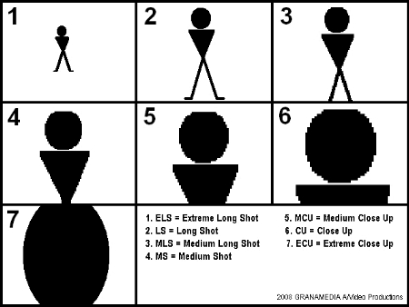

‘Slumdog Millionaire’ INTERNET TASK

Log on and find out the answers to the following questions

- Who is the director of the film?

- Who is the writer?

- What are the names of the main characters?

- Who are the actors who play them?

- Where does the story take place – (country and city)

- When was the film made?

- Did it win any awards? If so, which awards did it win and how many?

