Cause and Effect  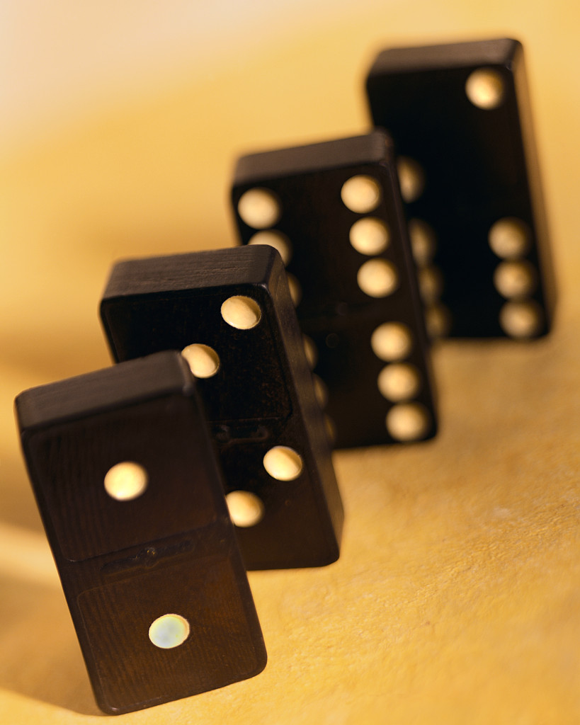  Cause is why something happened. Effect is what happened. (Sometimes the effect is listed first.) |  | Signal Questions  What happened?  Why did it happen?  What caused it to happen?  Signal Words  so because since therefore  if…then this led to reason why  as a result may be due to effect of consequently  for this reason
Compare and Contrast  Shows how two or more things are alike and/or how they are different. |  | Signal Questions  What things are being compared?  In what ways are they alike?  In what ways are they different?  Signal Words  same as similar alike as well as  not only…but also both instead of  either…or on the other hand different from as opposed to
Sequence  Describes items or events in order or tells the steps to follow to do something or make something. |  | Signal Questions  What items, events, or steps are listed?  Do they have to happen in this order?  Do they always happen in this order?  Signal Words  first second next then before  after finally following  not long after now soon
Problem and Solution  Tells about a problem (and sometimes says why there is a problem) then gives one or more possible solutions. |  | Signal Questions  What is the problem?  Why is this a problem?  Is anything being done to try to solve the problem?  What can be done to solve the problem?  Signal Words  question is… dilemma is…  the puzzle is… to solve this…  one answer is… one reason for the…
Description  A topic, idea, person, place, or thing is described by listing its features, characteristics, or examples. |  | Signal Questions  What specific topic, person, idea, or thing is being described?  How is it being described (what does it look like, how does it work, what does it do, etc)?  What is important to remember about it?  Signal Words  for instance such as… to begin with  an example to illustrate characteristics

